Case 2-A171-ME-Egypt-Woman on Camel-Hellenistic Terracotta-3rd-2nd century BCE

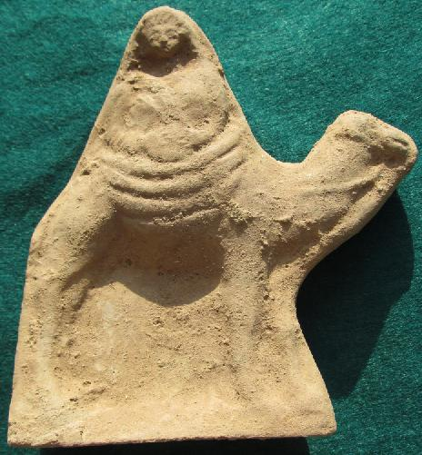
Fig. 1. Egypt-Alexandria-Woman on Camel-Hellenistic Terracotta-3rd-2nd century BCE

Case no.: 2
Accession Number: A171
Formal Label: Egypt-Alexandria-Woman on Camel-Hellenistic Terracotta-3rd-2nd century BCE
Display Description: This Hellenistic, 3rd-2nd century BCE, terracotta from Alexandria, Egypt, portrays a half-body female statuette wearing a tunic covered by a himation gown and secured on camelback by a heavily folded tapestry. She is portrayed as holding, with both hands, a tambourine, a musical instrument that was played by women accompanying ceremonial processions, especially in military triumphs, in the pre-Islamic Middle East.
LC Classification: NB94
Date or Time Horizon: 3rd-2nd century BCE
Geographical Area: Alexandria, Egypt
Map, GPS coordinates: 31.31298 30.05882

Fig. 2. Map of Alexandria, Egypt.
Cultural Affiliation: Hellenistic
Medium: Terracotta
Dimensions: 16 cm. x 13 cm.
Weight:
Condition: Original.
Provenance: Alexandria.
Discussion:
This seated female figure whose head is covered by a himation gown signifying a solemn ceremonial event is performing a musical ritual probably honoring a military audience apropos their victory. The rider on a camel is an iconographical emblem that represented honoring success in warfare in Hellenistic Arabia. Nabatea, Egypt and Syria (see Patrich 1990:73, n. 53).
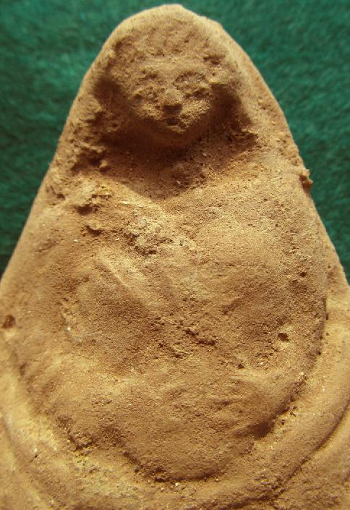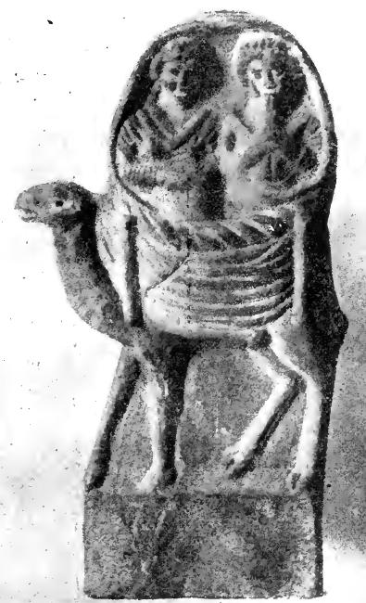
Fig. 3. Detail of figure 1 above. Fig. 4. This Hellenistic, 3rd-2nd century BCE, terracotta from Damascus, Syria, portrays two half-body female statuettes with the right female holding a flute and the left female holding a tambourine. They are wearing pleated gowns, with bouffant coiffures and are secured on camelback by a heavily folded tapestry. After Cumont 1917: 273, Fig. 94. (Musée du Louvre)
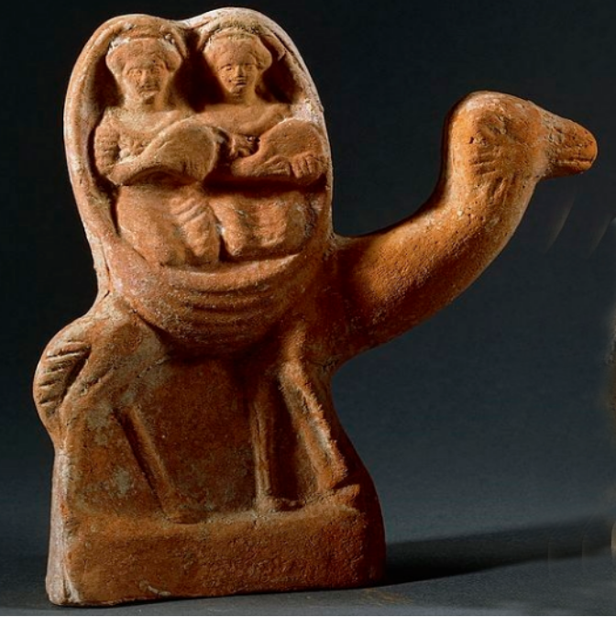
Fig. 5. This Hellenistic, 3rd-2nd century BCE, terracotta from Alexandria, Egypt portrays two half-body female statuettes holding, with both hands, tambourines and wearing pleated gowns, with bouffant coiffures. They are secured on camelback by a heavily folded tapestry. From Ny Carlsberg Glyptotek, Art Museum and History Museum, Tivolis, København V. https://foursquare.com/v/ny-carlsberg-glyptotek

References:
Cumont, Franz. 1917. Études Syriennes. Paris: A. Picard.

Patrich, Joseph. 1990. The formation of Nabatean art: prohibition of a graven image among the Nabateans. Jerusalem: Magnes Press, Hebrew University; Leiden; New York: E.J. Brill.

